CURRICULUM VITAE

GANESH .S

E-mail | : | Ganeshsss1988@gmail.com
Mobile | : | +919008094177
Address | : No. 28/1,10th C main , 6th block,
 |  | Rajajinagar,
 |  | Bangalore – 560010. Karnataka
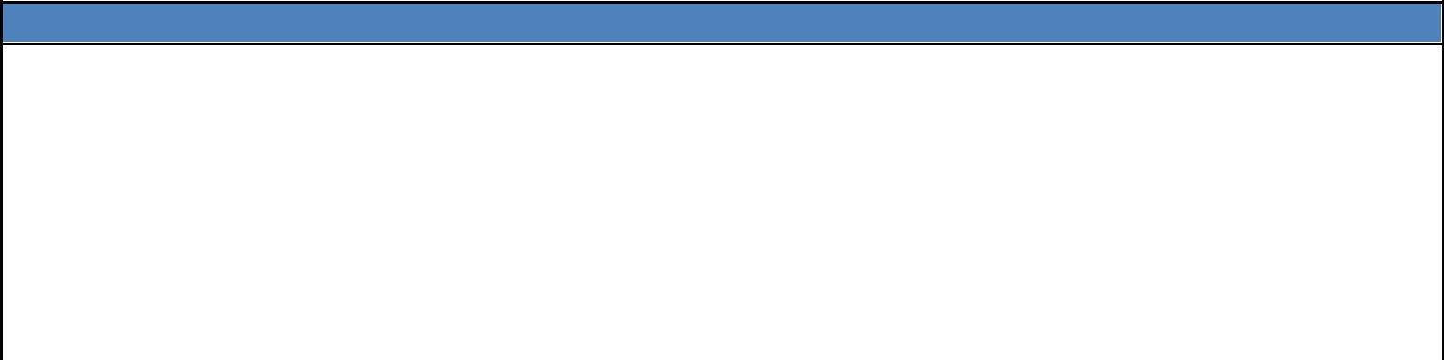
Introduction

- To acquire and utilize my knowledge skills and to take up responsibilities and challenges and contribute to the organization.
- Good team worker with practical creative ideas.


Experience

- Worked as an Application Verifier in COMED-K and KPSC Project Bangalore.

- Working in HDFC Bank, Bangalore since August 2008 as Sales Officer – Corporate Salary.


Academic Qualification
 |  | Course |  |  | Board Of Examination |  |  | Passed |  |  | Grade
 |  | Course |  |  | Board Of Examination |  |  | out |  |  | Grade
 |  | B. Com |  |  | Bangalore University (Seshadripuram |  | 2008 |  |  | 62.00%
 |  |  |  |  | Commerce College)
 |  | 2nd PUC |  |  | Bangalore University (Basaveshwara PU |  | 2005 |  |  | 63.00%
 |  |  |  |  | College)
 |  | S.S.L.C |  |  | Bangalore University (S L B S M High |  | 2003 |  |  | 69.00%
 |  |  |  |  | School)

 |  |  | Skill sets
• | Operating Systems | : | Windows Client (XP/Vista/7).
• | Applications | : | Microsoft Office 2003 and 2007
• | Additional | : | Tally.

PERSONAL DETAILS :

Father Name | : | Ganesh S
Gender | : | Male
Age & date of Birth | : 26 years, 21st April, 1988
Nationality | : | Indian
Passport | : | No
Languages Known | : Kannada, English, Hindi,Tamil and Telugu
Marital Status | : | Single

Declaration

I hereby declare that all the information furnished above is true and correct to the best of my knowledge and belief.

Place: Bangalore

Date: Ganesh .S

